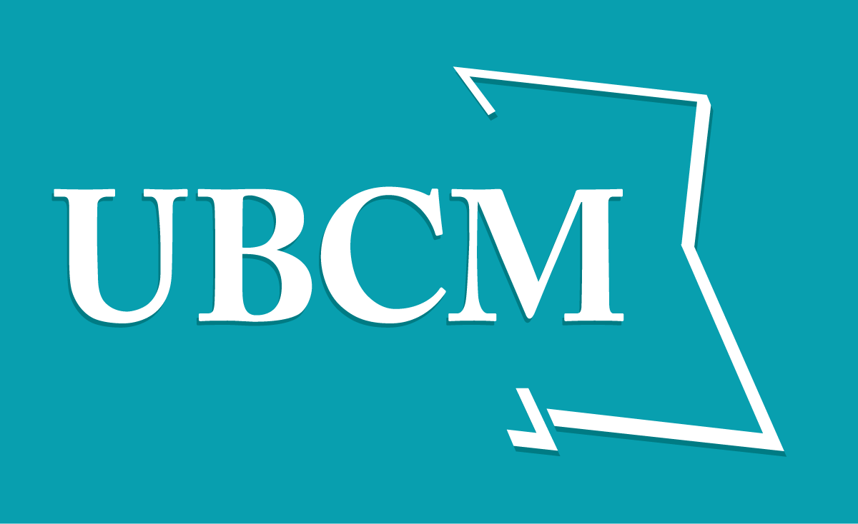 | 2011 COMMUNITY EXCELLENCE AWARDS  Category Worksheet  BEST PRACTICES, Website
________________________________________________________________

Name of Local Government: City of Terrace

Project/Program Title: Website Development & Upgrades

Website Address: http://www.terrace.ca/

Project Summary Paragraph
Please provide a summary of your project/program in 150 words or less.

Terrace.ca is a pre-existing website, developed by our website development contractor (Spark Design), and owned/maintained by the City of Terrace. Our website has gone thru some very comprehensive changes in the last 1-2 years in efforts to make it more useful and more accessible to site visitors, easier for municipal staff to maintain, up-to-date with current technologies, and to pioneer an innovative and interactive portal page that has high returns for all partners and stakeholders.

The City of Terrace is leading the way in its online efforts to offer a one stop website portal directing people to the four key websites in Terrace, and offering a new comprehensive shared events calendar.

Project Analysis
Please answer the question in 300 words or less in 11 pt Arial font (our judges value directness and brevity). If you experience difficulty answering a particular question, consider the aspects of your program that may relate to the question and show us how they are linked.

- PURPOSE

- If this was a pre-existing website, list the basic changes implemented. If this is a new website, tell us why you created it.

1/ NEW TERRACE PORTAL
- Partnered with Terrace Economic Development Authority, Kermodei Tourism Society, and the Terrace and District Chamber of Commerce to build a city portal at our terrace.ca domain; directs users to all four websites.

2/ NEW “SHARED” ONLINE EVENTS CALENDAR
- As part of the new portal, added a comprehensive events calendar which is shared with the local tourism website.
- Portal acts as a one stop shop for Terrace events; users can submit their events in one place & it feeds to multiple websites.

3/ IMPROVED ACCESSIBILITY
- Have been building more accessibility into our website by testing in a variety of custom browsers, including text only browsers, and older browsers;
- Made adjustments to ensure the site works well with Javascript disabled and/or CSS disabled.
- Integrated techniques to help ensure all content is available to all users, regardless of viewing device.
- Updated CSS files for print as well as font resizing (em sizing) + Add small, medium, large font size CSS buttons w/ separate CSS files for each.

4/ ACCESIBLE ANIMATED BANNER
- Added a Jquery photo banner for better visuals; staff can edit banners thru CMS.
- Jquery technology means site is more widely accessible on mobile devices.
- Banner photos also feed into the new portal.

5/ IMPROVED USABILITY ON HOME PAGE
- Re-designed layout, added news boxes for better usability. The news boxes are organized by department to permit greater access to news from each City department.

6/ IMPROVED AESTHETICS, ADDED FEATURES
- In addition to new home page layout and animated photo banners – added a site-wide photo gallery and integrated system to add dynamic slideshows to any page.
- Added a Senior Athletes section to highlight and promote our active residents.

6/ SECURITY & TECHNOLOGY UPGRADES
- Upgraded to 2011 versions of CMS software to maintain high security and use new features.
- Upgraded image editing tool, a new text editing and file management tools.

- How did you determine what your priorities were?

User feedback and in consultation with staff and our website developers.

- On average, how often is your website updated?

Daily. We have also decentralized our website maintenance process to allow a number of staff members to update the website as required ensuring it is as up to date as possible.

- CONCEPT
What do you want your website to accomplish?

Better communication with our residents by offering accurate and frequently updated information. This helps reduce staff time answering queries because many residents know they can find what they need on the website, and we can steer inquiries to the website. Our public posting form on our portal calendar increases and improves the content on the calendar and also reduces staff time required to keep it populated.

- EFFECTIVENESS
How is the website more efficient and/or effective than it was before? If this is a new site, explain what old processes for disseminating information or doing business you improved upon.

In the short time since the portal has been launched there have been some positive results.

The bounce rate is the number of visitors that leave the website right after entering. A high bounce rate means that visitors are not finding what they are looking for at first glance. Since the launch of the portal, the bounce rate has decreased by over 21%.

There are a number of other improvements as well such as:

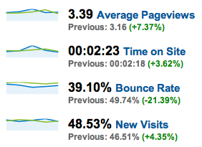

The website is more efficient in the publishing of events as well. With this new centralized calendar, staff time is reduced since all events are entered into one system and can be shared across multiple websites. As well, the public can post events for approval so the calendar will be a more comprehensive and accurate hub for events.

Since January 2011, the site has had excellent traffic and return traffic to the site. There have been:

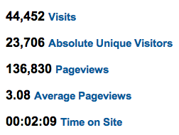
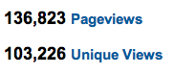

- ACCOUNTABILITY
How has this program/project improved upon accountability to the community's citizens?

It helps us offer better service and fulfill our mandate better than we could without it. It’s a quick way to announce information and make it available; we can also pre-set announcements to publish at a set date in the future if required. Council meeting agendas and minutes are posted on the website, and the Council meetings can be viewed live on our website via webcasting from Council Chambers. Public notices of events, leisure services programming, and documents such as our new Official Community Plan are all easily accessible for residents.

- AWARENESS
How has this program/project created more awareness in the community about local government actions?

The portal allows visitors to the community to easily access four different websites. Residents will find it easier to post events and to learn about events taking place in the community. Prospective business investors and people considering relocating to Terrace will find it easier to obtain the information they require by using the portal to access the four websites.

- INNOVATION
What makes your website innovative and creative? And/or what made your process innovative and creative?

The new portal is the result of a successful partnership effort and the new “shared” online events calendar is an innovative online product and service that – in its shared aspect – is a rarity amongst BC local governments. The result is benefitting all partner organizations as well as residents, businesses, visitors and the City of Terrace – including website maintenance staff!

1/ NEW TERRACE PORTAL
Through a committee of partners/stakeholders that included the Terrace Economic Development Authority, the Kermodei Tourism Society, the Terrace and District Chamber of Commerce, and the City of Terrace, we chose to create a city PORTAL at that domain which now directs users to all 4 individual websites.

2/ NEW “SHARED” ONLINE EVENTS CALENDAR
As part of the new portal, we added a comprehensive online events calendar that we share with the new VisitTerrace.com tourism website. The portal now acts as a one stop shop for all Terrace events so users can submit their own events in one place that feed to multiple websites. In addition to displaying on the Terrace Portal, all events automatically feed to an upcoming events sidebars on either or both the City website and the Kermodei Tourism website. This builds awareness and increases Search Engine Optimization for all related websites.

The events calendar is part of the terrace.ca CMS (Content Management System) which allows for easy moderation and automation. All publicly submitted events are held in queue for moderator approval. The website moderators at City Hall and at the Tourism organization are notified by email when an event is submitted. There is potential to share this events portal with more stakeholders in the future.

This is a great opportunity to increase efficiency and awareness, and alleviates the common dilemma of forcing users to post their events multiple times to multiple websites and force visitors to search in multiple places to find accurate event information.

- SUSTAINABILITY
What measures have you put in place to ensure the continued operation of this initiative? (e.g. staff time, resources, financial)

The events portal is maintained by multiple trained staff within the City as well as the Kermodei Tourism Office office. The City of Terrace website is easily maintained through the CMS which is easy to use. We reap financial savings by making content updates in-house which eliminates the cost and time-consumption taken up by dependence on a third party or web developer.

For web maintenance, we have online help pages to which current and future staff can refer. We maintain an annual budget for ‘upgrades’ that may be required or desired over time (mobile version of our site, enewsletter systems, social media, online payment systems, or CMS software upgrades).

- BEST PRACTICES
What sets this program/project apart as a winning idea? Why should it be considered a best practice, in comparison to other similar programs?

Leading the Pack/Pioneer
- We are the only municipality in northern BC with a contemporary portal that offers a shared online events calendar and public submit system.

Innovate
- We worked with our web development contractor to design a system that makes the multiple uses of our domain and our CMS configuration so that the portal is easy to navigate and easy to use on the front end as well as the back end, by multiple shared website moderators.

Partnerships
- We worked with the three other key stakeholder organizations in Terrace to create the shared Portal.

Vision
- We are looking at the needs of our target market now and in the future in designing and developing our online tools and services.

Teamwork
- Municipal Staff (Brad Hansen, Heather Nunn, Alisa Thompson, and Carmen Didier) worked alongside our partner organizations, our web development contractor (the Spark Design team) and share the portal events calendar administration and benefits with VisitTerrace / Kermodei Tourism.

- KNOWLEDGE SHARING
What helpful advice would you share with other communities looking to embark on a similar project?

- Keep it simple.
- Get a knowledgeable committee together – and communicate frequently so everyone is in the loop.
- Find an experienced web development company with whom and develop a long-term relationship and trust.
- Take time to understand all the options - Know that there are a lot of apples and oranges in web technology – that the medium is in constant evolution – and expect to go through a continuous learning curve.
- Don’t decide on price alone – get a demo of the CMS when possible.
- Find similar websites or features that you like and talk to those municipalities about what they like best and what they’d do differently.

- TELL US MORE
Please share any other information you think may help us better understand your submission.

We have the capacity to learn many things about the City website by investigating the Google Analytics tracking that has been integrated into the website. This info is valuable in attracting travelers, investment and growth in the community.

For example, this map shows concentrations of website visitors.

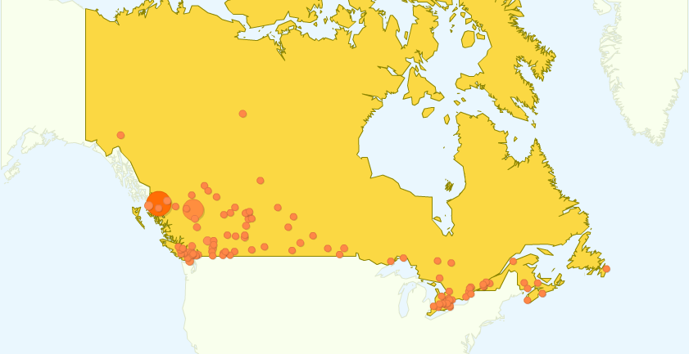

Knowing where visitors live, what browsers they are using, and what information they are looking for is important in continuing to improve the website and add innovations to the website to meet the needs of those seeking information. For example, should we see a steady growth in mobility devices being used to view the site, we could look at developing develop a mobile site in the future.

